**Report Title:**

**Improvement and Digitalization of Bugema University Library System**

**1. Introduction**

Bugema University Library serves as the knowledge hub for the university community, offering access to academic resources, research materials, and study spaces. However, traditional methods of managing library services, such as manual registration and borrowing processes, have introduced inefficiencies. To address these challenges and improve service delivery, a web-based library management system has been proposed. This system aims to streamline operations, enhance user experience, and support the university’s academic excellence.

**2. Project Description**

The Bugema University Library Web-Based System project focuses on transforming the library's operations from manual to digital processes. The project seeks to develop a system that will:

* Allow students and staff to register online for library access.
* Enable digital borrowing and returning of books.
* Provide an online catalog for searching available books and resources.
* Integrate student ID card issuance with the library registration.
* Offer user dashboards for tracking borrowed books and due dates.
* Manage bursary student privileges automatically.
* Allow administrators (librarians) to manage books, monitor borrowing activities, and generate reports.

The system will be accessible through desktop and mobile browsers to cater to all users, whether on or off-campus.

**3. Web-Based System Designs**

.

SITE MAP

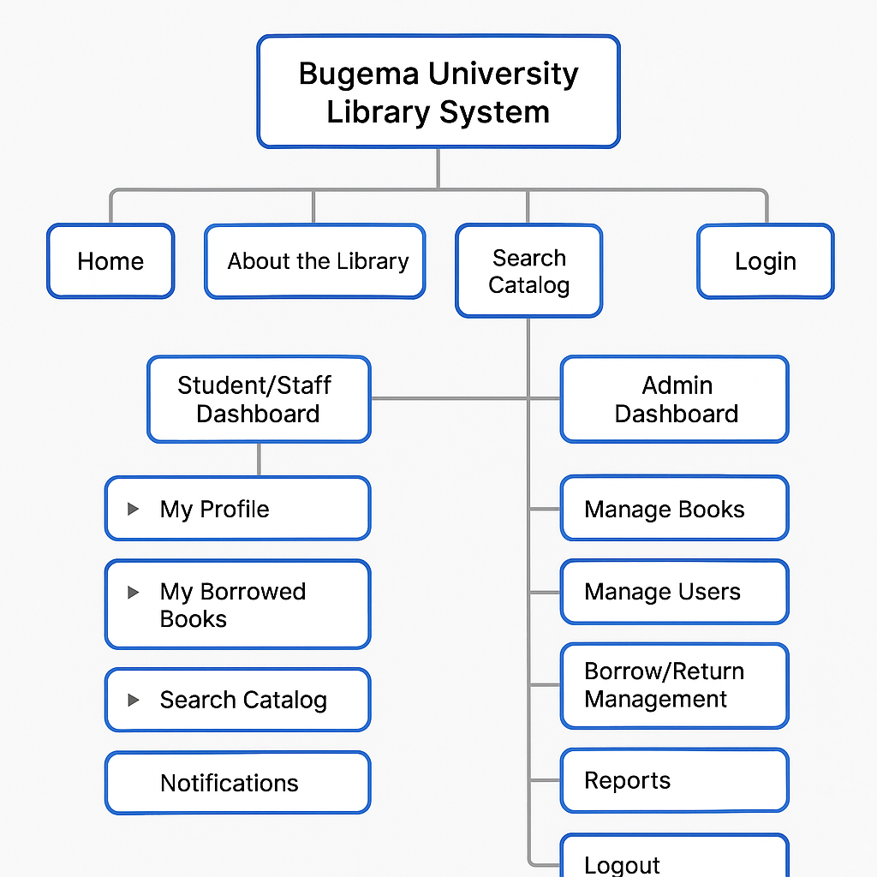

USE-CASE DIAGRAM

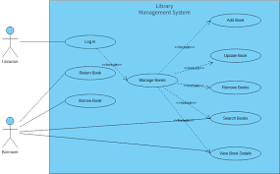

INTERFACE DESIGN

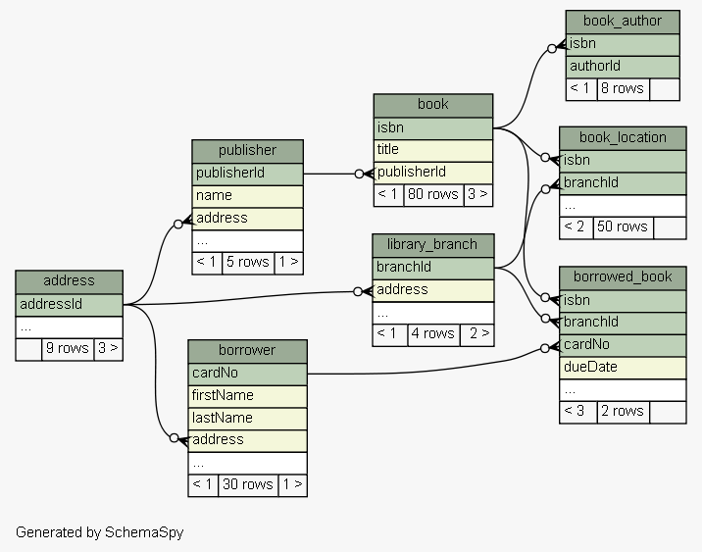

+------------+ +------------------+ +--------------+

| Users | 1 * | Borrow Records | * 1 | Books |

+------------+ +------------------+ +--------------+

id (PK) id (PK) id (PK)

username user_id (FK) title

password book_id (FK) author

role borrow_date isbn

full_name return_date available_copies

email status

**(Basic visual idea of key pages)**

* **Login Page:**  
  Form for users to log in with student ID and password.
* **Student Dashboard:**
  + View borrowed books.
  + Search books.
  + See due dates and fine status.
* **Admin Dashboard:**
  + Add new books.
  + Approve or manage users.
  + Generate borrowing reports.

**4. Conclusion**

The proposed Bugema University Library Web-Based System will bring greater efficiency, accessibility, and accuracy to library operations. By digitalizing core services and integrating student management, the system will significantly improve the user experience for students, staff, and administrators alike. This project supports Bugema University’s vision of academic excellence in a modern digital environment.